HD 117207

HD 117207 is a 1.04 M☉, G8 IV star59. Based on 42 RV HIRES measurements obtained between 1997 and 2004, a study performed in 2005 (hereafter M05)59 reported a GP signal with a period of 2627 ± 63.51 days, a minimum mass of 2.06 MJup and an eccentricity of 0.16 ± 0.05. The CH survey reported a GP signal with properties close to those reported in the M05 study.

In the present study, in addition to the M05’s dataset, 96 RV HARPS measurements obtained between 2004 and 2019 were used. DPASS and MCMC (1000 walkers and 300000 iterations) were used to fit the data. The properties of HD 117207b are close to those reported in the CH survey.

The fits are shown in Fig 1, and the corner plot in Fig 2, and the results summarized in Table 1.

Conclusion: The properties used in the CH survey for HD 117207b are confirmed.

Figure 1: Left: fit of the HD 117207 RV with DPASS. Red - Hir94, green - H03, blue - H15. The blue curve shows the best fit. Right: fit of the HD 117207 RV using MCMC. The black curve shows the best fit. The colorbar corresponds to the log-likelihood of the fits. The gray dotted line indicates the end of the CH survey.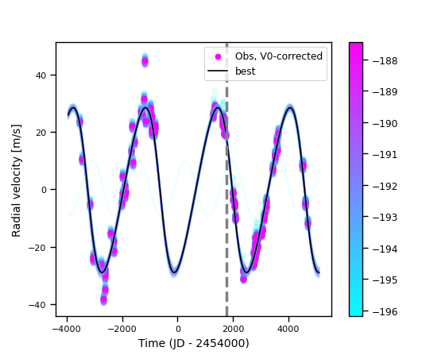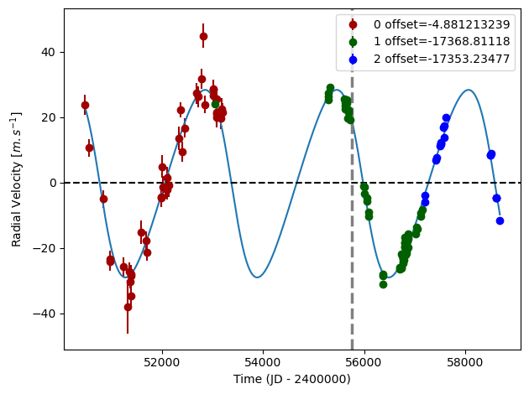

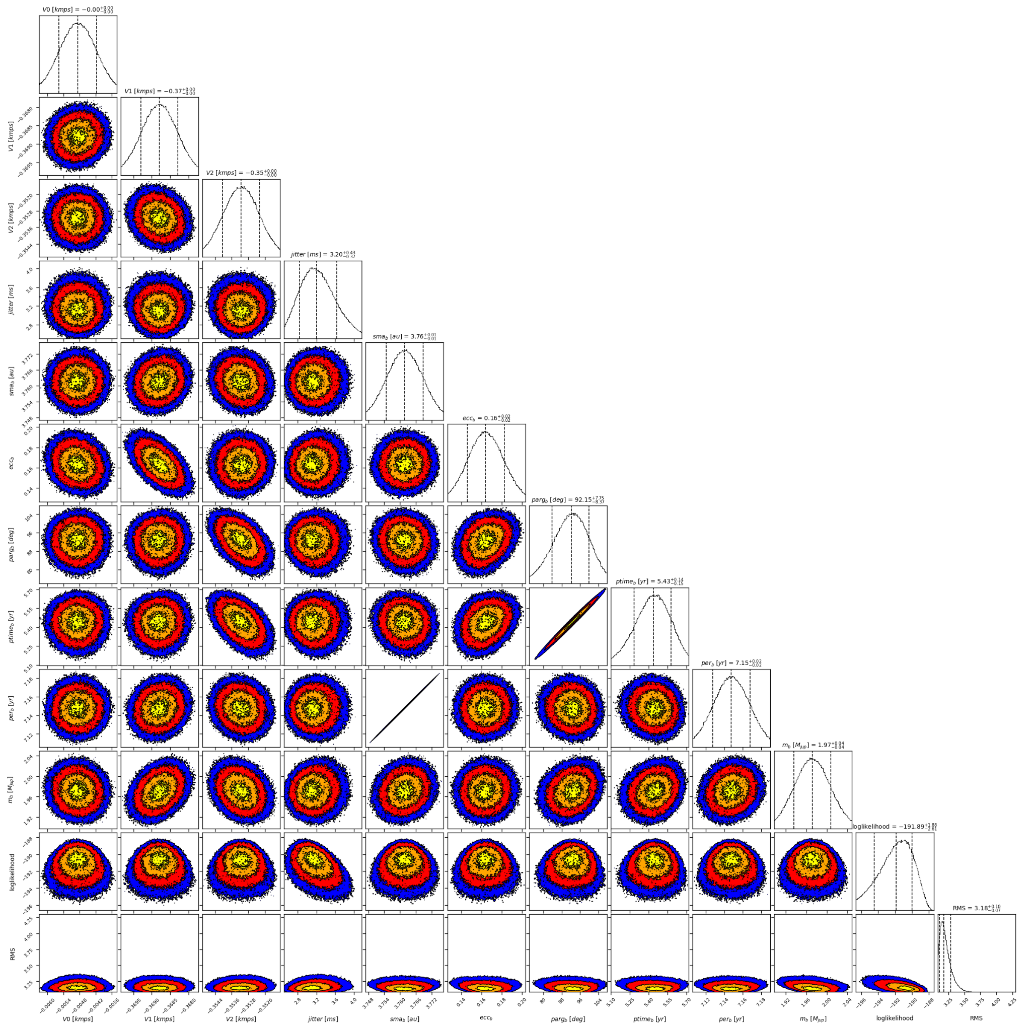

Figure 2: Corner plot of posteriors for the one-planet model MCMC fit of HD 117207 RV data.

| Parameter | Priors | | Posteriors | | CH survey |
| --- | --- | --- | --- | --- | --- |
|  | DPASS | MCMC | DPASS | MCMC |  |
| *a* (au) | [0,100] | [2,10] | 3.76 | 3.76 ± 0.01 | 3.8 |
| Msin(i) (MJup) | [0,100] | [0,10] | 1.95 | 1.97 ± 0.04 | 1.82 |
| Eccentricity | [0,0.9] | [0,0.95] | 0.15 | 0.16 ± 0.02 | 0.14 |
| Instrumentals offsets (km/s) | [-60,60] | Hir94: [-1,1]  H03: [-18,-16]  H15: [-18,-16] | Hir94: -0.005  H03: -17.369  H15: -17.353 | Hir94: -0.005± 0.001  H03: -17.369± 0.001  H15: -17.353± 0.001 |  |
| Stellar jitter (m/s) | [0,40] | [0,20] | 2.9 | 3.2 ± 0.04 |  |
| Argument of periastron (°) | [0,360] | [0,360] | 93 | 92± 8 |  |
| Phase | [0,1] | [0,1] | 0.43 | 0.76 ± 0.02 |  |

Table 1: HD 117207. Summary of priors and posteriors obtained with DPASS and MCMC, compared to the properties reported by the CH Survey.

References

1. Marcy, G. Five New Extrasolar Planets. *Astrophys. J.* 619, 570-584 (2005).